10.1.13 Editors - Shader Editor - Header - Add Menu - Group
Add menu - Group 1
Make Group 1
Ungroup 2
List of Node Groups 2

Add menu - Group
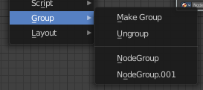
Node groups allows you to group different nodes of the material together to reduce the visual complexity. A node group acts like any other node.
Material node groups should not include Input nodes, like Image nodes, or Output nodes.
If you include a source node in your group, you will end up having the source node appearing twice: once inside the group, and once outside the group in the new material node tree.
If you include an output node in the group, there will not be an output socket available from the group!

Make Group
Groups the selected nodes together.
Select the nodes that you want to group together. Choose Make Group. You will now see a green background. This indicates that the group is created, and that you are in edit mode for the group now.



To exit the group edit mode press Tab key, or choose Toggle Edit Group menu item in the sidebar in the Relations tab in the Group panel. That way you can also enter the Group Edit mode again.




There is a third way to enter the group edit mode. Click at the right upper icon of the group node.


A group can be further collapsed by clicking at the triangle button in the upper left corner.


The group can be renamed in the sidebar in the Item tab and in the Properties tab in the Node panel.

Ungroup
Ungroups an existing group. You need to be outside of the group edit mode.

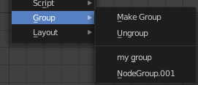
List of Node Groups
Once you have created a node group it will also show up in the group menu. Groups can be inserted to other materials too.

